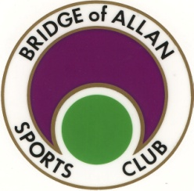

BRIDGE of ALLAN SPORTS CLUB

AUGUST 2015 NEWSLETTER

Family Fun All Year Round

GET YOUR NAME DOWN QUICK



**PADEL TENNIS UPDATE**

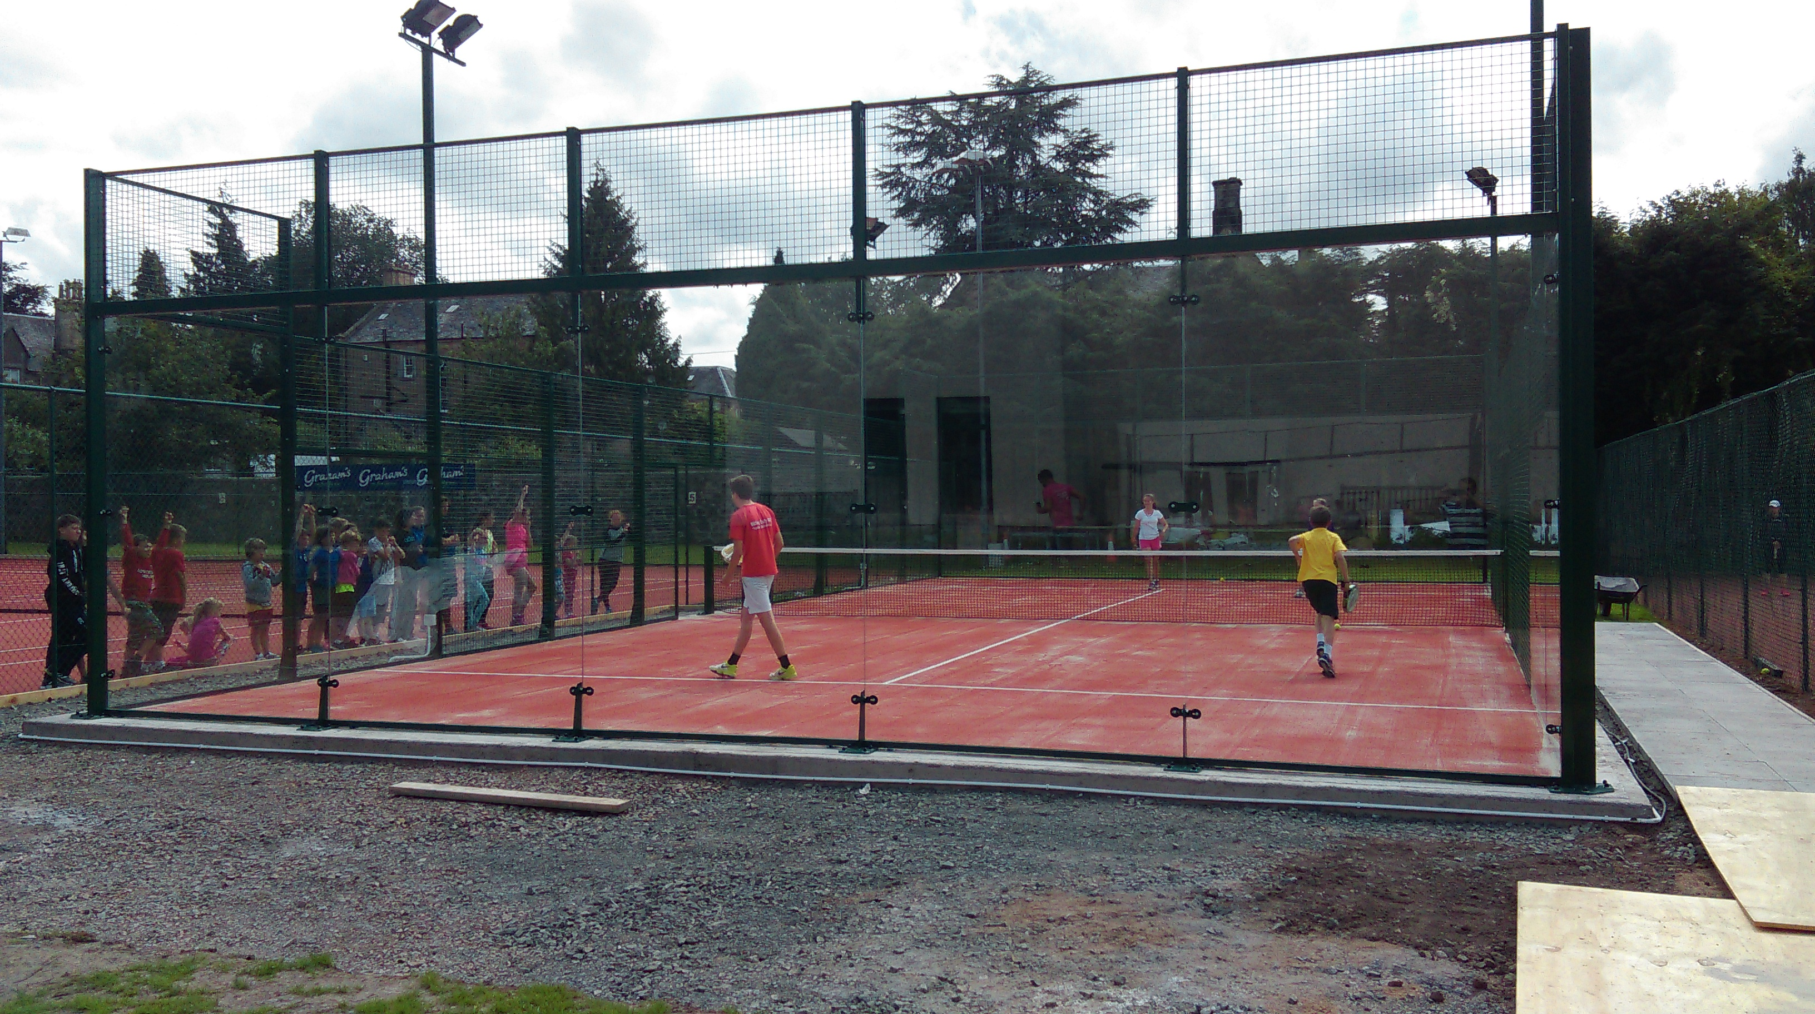

The Padel Court is open and proving to be very popular.

Padel Bats and Balls are available for hire from behind the bar at £1.00 per bat for members.

Non Members can book the court for a fee of £5.00 per player, this includes equipment hire.

Padel Bats are also for sale from the Club. See Steve for details.

On Line Booking will be available by the end of this week – **a separate e-mail will be sent out soon**.

Contact Steve for information on –

Free Starter Sessions

The Official Opening of the Court is planned for Saturday 12th September 2015. The day starts at 2.00pm and will include –

* Reception upon arrival
* Official Opening
* Exhibition Match
* Tennis and squash player exhibition matches

Followed by a BBQ and Music

A NOTE FOR YOUR DIARY

ANNUAL DINNER DANCE

To be held at the Bologna Restaurant again on Friday 18th December 2015.

More information will follow.

This proved to be very enjoyable last year with a good turn out of members. Please note the date and I will get posters and e-mails out nearer the time.

1

BRIDGE of ALLAN SPORTS CLUB

AUGUST 2015 NEWSLETTER

Family Fun All Year Round

1

page

CURRENT MEMBERSHIP FIGURES

JUNIOR - 41

MIDI JUNIOR - 34

MINI JUNIOR - 39

SOCIAL - 39

SENIOR - 274

STUDENT - 7

YOUNG PERSON - 13

TOTAL - 447

This time last year the total was 400 and in 2013 it was 373.

New members’ names are posted on the notice board in the clubhouse.

MATCH v EDINBURGH SPORTS CLUB

SATURDAY 29th AUGUST – 2pm ONWARDS

SQUASH, RACKETBALL and PADEL

This match is being re-instated this year and will be as much social as it is competitive.

The plan is to finish with a BBQ and Music

There is a list behind the bar – please add your name if you are interested in playing or e-mail Steve on manager@boasc.com

PLEASE NOTE - TENNIS COURT INFORMATION

Next week, we are hosting the Annual, Tennis Central Closed Tournament. 3 clay courts will be booked from 9.30am until 8.30pm Monday to Friday and then 9.30am to 4.00pm on Saturday.

Once again, thank you for your patience and understanding.

PLEASE NOTE - SQUASH COURT INFORMATION

All squash Courts will be being used for the Annual Central Closed Tournament on

Saturday 22nd and Sunday 23rd August 2015, from 9.30am through till around 8.00pm.

Thank you for your patience and understanding.

Spectators would be most welcome – there is some very good squash to be seen.

DON’T FORGET TO VISIT THE CLUB WEBSITE – [WWW.BOASC.CO.UK](http://WWW.BOASC.CO.UK) – WHERE YOU WILL ALSO FIND NEWS, INFORMATION ABOUT THE CLUB AND FORTHCOMING EVENTS.

2

2