

BRIDGE of ALLAN SPORTS CLUB

DECEMBER 2015 NEWSLETTER

Family Fun All Year Round



HISTORY MAKERS

SQUASH history was made at Minewood Pavilion after Scotland age group international Sabine Mackenzie and her 15 year-old son Keir (left) became the first mother and son combination to win their respective singles matches for a Bridge of Allan squash club side.

**JUNIOR FESTIVE FUN PARTY**

Sunday 27th December 2015

2.00pm – 5.00pm

All Junior Members Welcome

Put your Hand / Eye co-ordination skills

to the test in an afternoon of

TV’s, ‘The Cube’ style games.

(adapted for all Junior age groups)

Food will be available

More details to follow

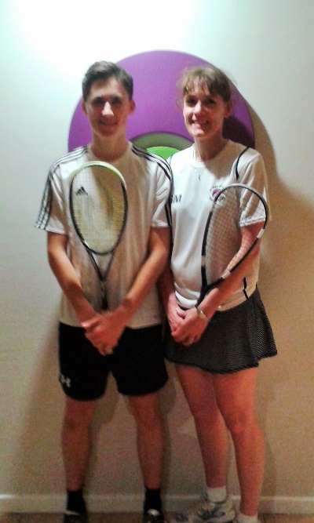



CHRISTMAS OPENING HOURS

CHRISTMAS EVE: 10.00am – 8.00pm

CHRISTMAS DAY: CLOSED

BOXING DAY: CLOSED

27th – 30th DECEMBER: 10.00am – 10.00pm

31st DECEMBER: 10.00am – 8.00pm

1st JANUARY: CLOSED

2nd JANUARY: 11.00am – 10.00pm

**50 / 50 CLUB**

DECEMBER WINNER OF £80.00 –

To be drawn on 16th December

WANT TO BE IN THE DRAW?

Contact Steve Ingram for more information at

manager@boasc.com

1



BRIDGE of ALLAN SPORTS CLUB

DECEMBER 2015 NEWSLETTER

Family Fun All Year Round

2

**CLUB POLO SHIRTS**

WE HAVE A FEW LARGE

SIZE POLO SHIRTS

AVAILABLE FOR

MEMBERS TO BUY.

ONLY £10.00

WHILE STOCK LASTS

PLEASE ASK STEVE

OR BAR STAFF IF

YOU ARE INTERESTED.

A SAMPLE IS BEHIND THE BAR TO TRY ON IF YOU WISH

**CURRENT MEMBERSHIP FIGURES**

**DECEMBER 2015**

JUNIOR - 41 MIDI JUNIOR - 32

MINI JUNIOR - 34 SOCIAL - 32

SENIOR - 272 STUDENT - 15

YOUNG PERSON - 16

**TOTAL - 442**

**New Members in November were** –

Robert Stewart – Senior Mark Quinn - Senior

Rohan Shamoo – Mini Iain Graydon - Senior

Kamran Shamoo - Mini Jacqueline McKenna

Allan Robertson - Senior Elizabeth Kierney - Soc

Geoff Nisbet – Young person Peter Kierney - Social

Robbie Mailer – Senior Bryan Clark - Senior

John Stephen – Senior Lyndsay Mailer - Senior

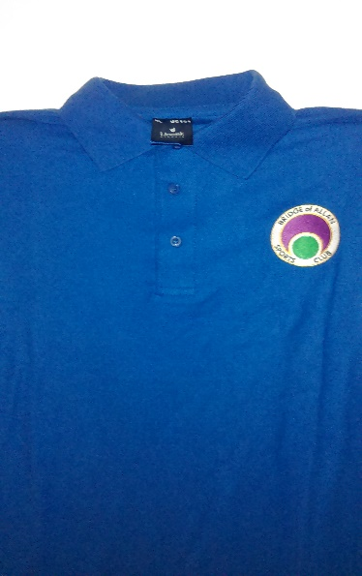



CONGRATULATIONS TO THE DAVIS CUP TEAM.

REMEMBER TO ‘OPT IN’ TO THE WIMBLEDON BALLOT FOR 2016

YOU WILL NEED TO LOG IN TO THE LTA WEBSITE TO ‘OPT IN’

YOU WILL NEED TO HAVE A BTM MEMBERSHIP NUMBER

EMAIL STEVE AT [manager@boasc.com](mailto:manager@boasc.com) FOR FULL INFORMATION

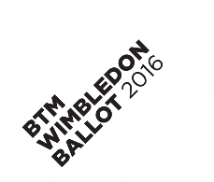

2