These activity weeks will give children a chance to play and develop their skills across a range of sports including;
- Tennis
- Padel Tennis
- Squash
- Table tennis
- Racketball
- PLUS – Other Fun Activities
  - Swedish Long Ball
  - Football
  - Hockey
Each day will be structured with different activities with a morning break and a lunch break. Children should dress in sports gear and MUST have indoor as well as outdoor shoes.
Snacks, lunches and drinks can be purchased from the Club or you can bring a packed lunch
Cost Per Week
Members : £75
Non Members: £90
Club Membership
The non member’s entrance fee includes 3 months membership
to the Club from first day of the Camp attended.

Bridge of Allan Sports Club

Summer Camps

Week 1  10th – 14th July | 9.00am – 3.00pm | 5 days | £75.00 – Members  £90.00 – Non Members
Week 2  17th – 22st July | 9.00am – 3.00pm | 5 days | £75.00 – Members  £90.00 – Non Members
Week 3  7th – 11th Aug | 9.00am – 3.00pm | 5 days | £75.00 – Members  £90.00 – Non Members
Week 4  14th – 18th Aug | 9.00am – 3.00pm | 5 days | £75.00 – Members  £90.00 – Non Members
Please tick box/boxes applicable to your child’s registration

Please note;

Photographs may be taken for Club advertising purpose. If you do not consent to photographs of your child(ren) to be taken please email -
manager@boasc.com

Parents are required to sign children in and out, at reception, with Head Coach / Club Manager every day

Please book early to avoid disappointment.
First Name: | Surname: | D.O.B.
Address:

Post Code:
Phone: Mobile:
Club Membership Number (if member)........................(available from Steve Ingram at the Club).
Email (to enable communication about classes):
Emergency contact:
Name:
Address:

Phone: Mobile:
Medical Info:

Parent / guardian: I acknowledge that the above information is correct and consent my child to take part in sporting activity at Bridge of Allan Sports Club.

Signed:_______________________________________Date:______________________________________

Please submit forms at the club or send, with payment, to: Bridge of Allan Sports Club, Minewood Pavilion, Mine Road, Bridge of Allan, FK9 4DT
Cheque, cash or card payments are all accepted
Cheques payable to Bridge of Allan Sports Club

Bridge of Allan Sports Club

Summer Camps
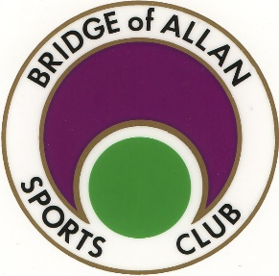
Week 1 : 10th – 14th July 2017
Week 2 : 17th – 21st July 2017
Week 3 : 7th – 11th Aug 2017
Week 4 : 14th – 18th Aug 2017
9.00am - 3.00pm
(For children between 5-13 years)
PLEASE NOTE THAT WE CAN ONLY TAKE BOOKINGS FOR FULL WEEK ATTENDANCES

